**Saurabh joshi 7249 se comp b**

**INNER MONOLOGUE**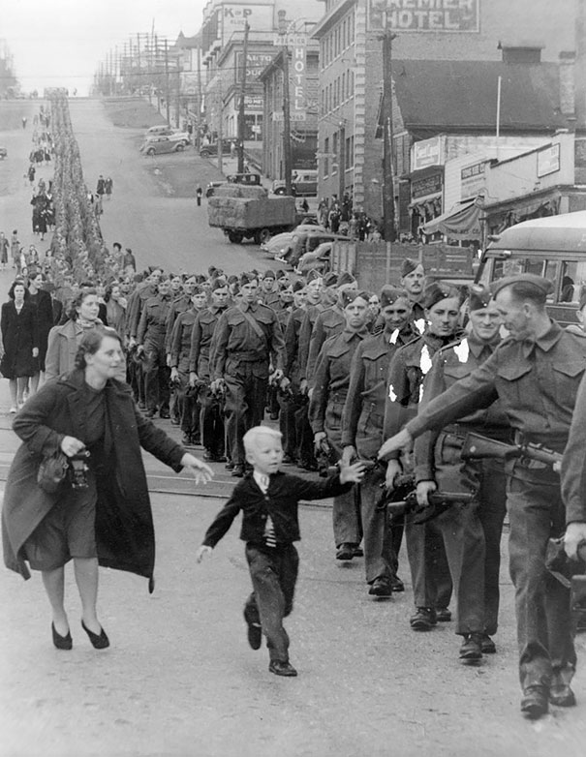

Hey father, where are you going. Where all of you are going? What they are holding in their hands? Mommy!! Please tell me!! Guns!! War!! When will he return? Whom with I play after till then?

With whom will I go to the church? Hey mom!! Tell father to stay. Father!! Wait!! I also want to go with you. I won’t complain about anything. Please take me with you. I will also participate in war with you. Please take me with you. I like the uniform you all are wearing, the way you all are marching. I also want to be like you all. Please take me with you!